SIMATS ENGINEERING
ASSESSMENT TOOL 1: Expert System Development Project
COURSE NAME: ARTIFICIAL INTELLIGENCE COURSE CODE: MLA0101
AND EXPERT SYSTEMS

COURSE OUTCOME COVERED
CO 5: Construct rule-based expert systems using production rules, forward and backward chaining, and by distinguishing procedural and non-procedural paradigms across development stages.(BTL 3)
Assessment Tool Weightage: 40%

Total Marks: 100 Time: 90 Mins
No. of Questions: 1
Annexure A
Expert System Development Project

Code of Conduct:
I P.N.V.CHAVIN/ 192525310 (Name / Reg No) certify that this submission is my original work and that I have adhered to the guidelines specified for this assessment.
I understand that any violation of academic integrity rules will result in disciplinary action.
Signature of the student: P.N.V.CHAVIN
Criterion | Weightage | Marks Obtained
1. Problem Analysis and Domain Understanding | 10%
2. Knowledge Acquisition and Knowledge Representation | 10%
3. Production Rule / Knowledge Base Design | 15%
4. Prolog Implementation and Programming | 15%
5. Forward Chaining Implementation and Demonstration | 10%
6. Backward Chaining Implementation and Demonstration | 10%
7. Procedural and Non-Procedural Paradigm Analysis | 10%
8. Unification, Backtracking and Inference Accuracy | 10%
9. Testing, Results and System Demonstration | 5%
10. Documentation, GitHub Repository and Technical  Presentation | 5%
Total | 100%
Signature of the Faculty Total Marks Awarded
ANSWER ANY ONE OF THE FOLLOWING
Tool: SWI-Prolog
Usage of Prolog: Students shall use Prolog to develop a rule-based expert system by representing domain knowledge as facts and production rules, and implementing reasoning through forward and backward chaining. The project should demonstrate Prolog's declarative/non-procedural nature, logical inference, rule matching, and automated conclusion generation.
S.No. | Scenario-Based Expert System Development Question
1 | Medical Diagnosis Expert System:  Develop a rule-based expert system that identifies possible diseases based on symptoms, patient observations, and basic clinical information. Represent domain knowledge using production rules and implement both forward and backward chaining to derive conclusions.
2 | Crop Disease Advisory System:  Develop an expert system that identifies possible crop diseases based on leaf symptoms, soil conditions, weather conditions, and visible plant characteristics. Construct suitable production rules and demonstrate diagnosis using forward and backward chaining.
3 | Automobile Fault Diagnosis System:  Design an expert system that identifies probable vehicle faults based on symptoms such as engine noise, starting problems, warning indicators, abnormal vibration, and reduced mileage. Implement the knowledge base using production rules and compare forward and backward reasoning.
4 | Student Academic Advisory System:  Develop an expert system that recommends suitable academic interventions based on attendance, internal marks, assignment performance, learning difficulties, and previous academic performance. Use production rules and demonstrate both forward and backward chaining.
5 | Cybersecurity Threat Diagnosis System:  Construct a rule-based expert system that identifies possible cybersecurity threats from events such as repeated login failures, unusual network traffic, suspicious file activity, and unauthorized access attempts. Implement production rules and demonstrate how forward and backward chaining arrive at a threat classification.
Report Format:

Stage | Student Activity | Expected Output
1. Domain  Analysis | Identify the problem domain, entities, facts, symptoms/conditions, and possible conclusions. | Problem definition and domain model
2. Knowledge  Acquisition | Collect domain knowledge from reliable sources or domain experts. | Knowledge  specification
3. Knowledge  Representation | Convert domain knowledge into IF–THEN production rules. | Knowledge base
4. Inference  Design | Implement forward chaining and backward chaining. | Inference engine
5. Paradigm  Analysis | Distinguish how the solution can be expressed using procedural and non-procedural approaches. | Paradigm comparison
6. System  Development | Integrate the knowledge base, inference engine, user interface, and explanation facility. | Working expert system
7. Testing | Test the system using multiple facts and scenarios. | Test cases and outputs
8. Evaluation | Analyze correctness, coverage, consistency, and reasoning performance. | Evaluation results
9. Documentation | Prepare technical documentation and GitHub repository. | Project report +  GitHub
10. Demonstration | Demonstrate the system and explain the reasoning process. | Project presentation/viva

4. STUDENT ACADEMIC ADVISORY SYSTEM

Domain Analysis
The Student Academic Advisory System focuses on identifying students who require academic support and recommending suitable interventions. The system considers factors such as attendance, internal marks, assignment performance, learning difficulties, and previous academic performance. Based on these factors, appropriate interventions such as academic counselling, remedial classes, additional assignments, mentoring, and study guidance are recommended.
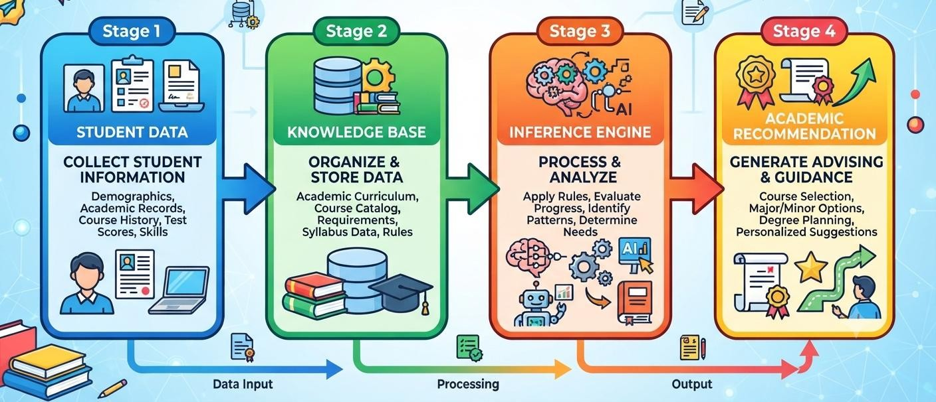

Knowledge Acquisition
Knowledge for the system is acquired from academic guidelines, teacher expertise, and commonly followed academic intervention practices. The collected knowledge describes relationships between student performance indicators and appropriate interventions. For example, consistently low internal marks may indicate the need for remedial academic support, while poor attendance may require attendance counselling.

Knowledge Representation
The acquired knowledge is represented using production rules in the form of IF–THEN statements. These rules connect student academic conditions with appropriate recommendations. For example, a rule can be represented as: IF attendance is low AND internal marks are low THEN recommend academic counselling and remedial classes. This rule-based representation allows the system to make recommendations systematically.
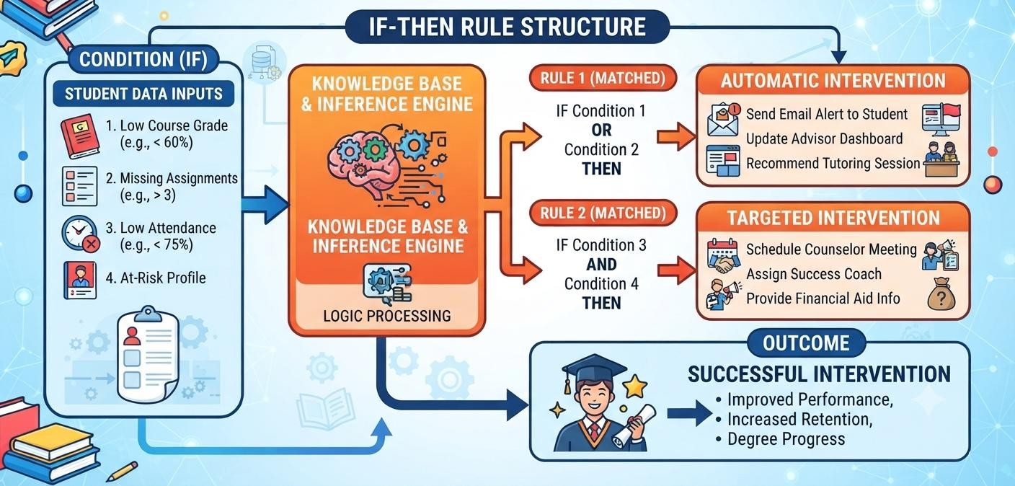

Inference Design
The system uses both forward chaining and backward chaining for reasoning. In forward chaining, the system begins with known student information and applies relevant rules to derive an appropriate intervention. In backward chaining, the system begins with a possible recommendation and works backward to determine whether the student's conditions satisfy the rules required for that recommendation.
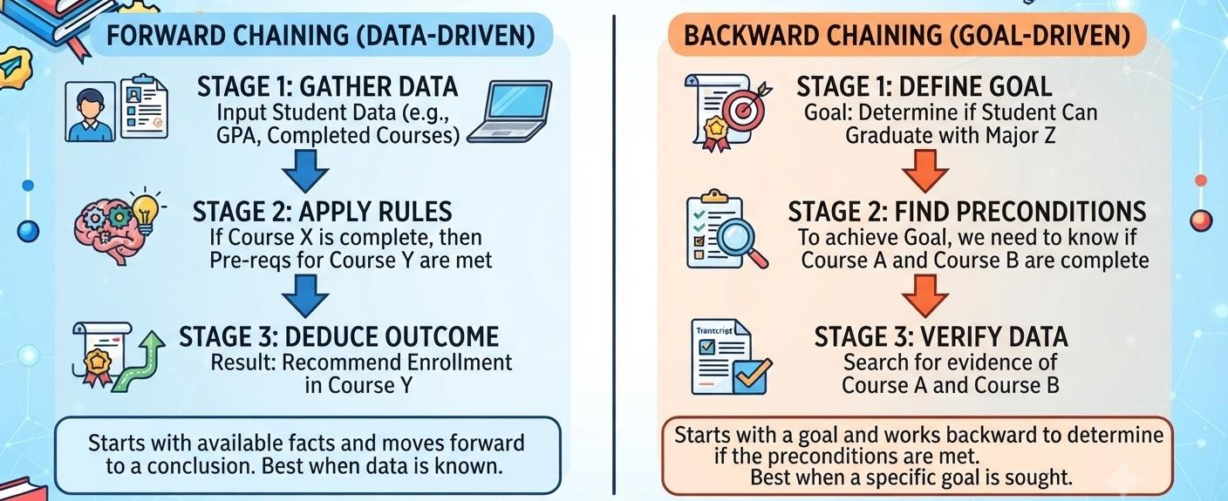

Paradigm Analysis
A rule-based expert system paradigm is selected because academic advisory decisions can be effectively represented using clearly defined conditions and recommendations. Production rules provide a transparent reasoning mechanism, allowing the recommendations generated by the system to be easily understood and verified. Forward and backward chaining provide two different approaches for reaching the required conclusions.

System Development
The system is developed with major components including a student information input module, knowledge base, production-rule database, inference engine, and recommendation module. Student details such as attendance, marks, assignment performance, learning difficulties, and previous performance are provided as inputs. The inference engine evaluates these inputs against the knowledge base and produces suitable academic interventions.
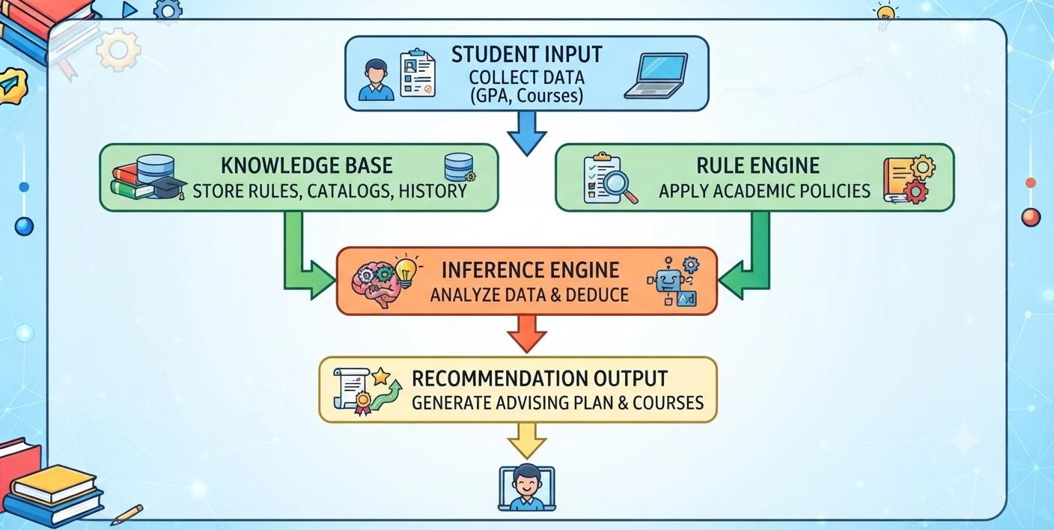

Testing
The system is tested using different student academic scenarios. Test cases include students with low attendance, poor internal marks, weak assignment performance, learning difficulties, and consistently poor previous academic performance. The system is checked to ensure that the appropriate production rules are activated and that the resulting recommendations are correct.

Evaluation
The system is evaluated based on the accuracy and consistency of its recommendations and the correctness of its inference process. The results obtained through forward and backward chaining are compared with the expected recommendations. The evaluation determines whether the system can effectively identify academic difficulties and provide appropriate interventions.

Documentation
The system documentation includes the problem statement, objectives, domain analysis, knowledge acquisition process, production rules, knowledge representation, inference mechanisms, system design, implementation details, test cases, results, and evaluation. Examples of forward and backward chaining are also documented to clearly demonstrate the reasoning process.

Demonstration
The completed Student Academic Advisory System is demonstrated using sample student academic records. The demonstration shows how the system processes student information, applies the production rules, and generates appropriate academic interventions. Both forward chaining and backward chaining are demonstrated using suitable student cases to verify the expert system's reasoning capabilities.

EVALUATION RUBRICS:

Criterion | Weighta ge (%) | Excellent | Good | Average | Poor
1. Problem  Analysis and  Domain  Understanding | 10% | 9–10% – Clearly analyzes the realworld problem, domain entities, facts, conditions, goals, and expected conclusions. | 7–8% – Good understanding of the domain with minor omissions. | 5–6% – Basic domain understanding with several missing elements. | 0–4% – Poor or incorrect understanding of the problem domain.
2. Knowledge  Acquisition and  Representation | 10% | 9–10% – Acquires relevant domain knowledge and represents it accurately using well-structured Prolog facts and rules. | 7–8% – Knowledge is appropriately represented with minor gaps. | 5–6% – Basic knowledge representation with missing or unclear facts/rules. | 0–4% –  Inadequate or inappropriate knowledge representation.
3. Production  Rule /  Knowledge  Base Design | 15% | 13–15% – Develops a comprehensive, consistent, and logically structured production-rule knowledge base with appropriate facts and rules. | 10–12% – Welldesigned knowledge base with minor inconsistencie s or omissions. | 7–9% – Basic rule base developed but several rules are incomplete or unclear. | 0–6% –  Knowledge base is incomplete, inconsistent, or inappropriate.
4. Prolog  Implementation | 15% | 13–15% –  Implements a fully functional expert system using Prolog facts, predicates, rules, variables, unification, and backtracking effectively. | 10–12% – Functional Prolog implementatio n with minor technical issues. | 7–9% – Basic implementation works with limited use of  Prolog features. | 0–6% –  Implementation is incomplete, incorrect, or nonfunctional.

5. Forward  Chaining | 10% | 9–10% – Correctly implements and demonstrates forward chaining from initial facts through applicable rules to final conclusions. | 7–8% – Forward chaining works correctly with minor limitations. | 5–6% – Basic forward reasoning demonstrated but with incomplete rule processing. | 0–4% – Forward chaining is missing or incorrectly implemented.
6. Backward  Chaining | 10% | 9–10% –  Effectively demonstrates goaldriven backward chaining using Prolog's inference mechanism and  clearly traces the reasoning process. | 7–8% – Backward chaining works correctly with minor gaps. | 5–6% – Basic backward reasoning demonstrated with limited explanation. | 0–4% –  Backward  chaining is missing or incorrectly implemented.
7. Procedural and NonProcedural  Paradigm  Analysis | 10% | 9–10% – Clearly distinguishes procedural and declarative/nonprocedural approaches and demonstrates their application in the Prolog system. | 7–8% –  Provides a good distinction with minor conceptual gaps. | 5–6% – Basic distinction is explained but lacks practical demonstration. | 0–4% – Paradigms are misunderstood or not addressed.
8. Inference,  Unification and  Reasoning  Accuracy | 10% | 9–10% – Produces accurate conclusions using unification, backtracking, and logical inference across diverse test cases. | 7–8% –  Reasoning is mostly accurate with minor errors. | 5–6% – Basic inference works but produces occasional incorrect results. | 0–4% –  Inference is unreliable or incorrect.
9. Testing,  Results and  System  Demonstration | 5% | 5% – Provides comprehensive test cases, accurate outputs, reasoning traces, and a convincing live demonstration. | 4% – Good testing and demonstration with minor gaps. | 2–3% – Limited test cases and basic demonstration. | 0–1% – Testing or demonstration  is  missing/inadequa te.
10.  Documentation,  GitHub and  Technical  Presentation | 5% | 5% – Complete documentation, well-organized GitHub repository, clear code, references, and professional presentation. | 4% – Good documentatio n and repository with minor issues. | 2–3% – Basic documentation/re pository with several omissions. | 0–1% – Poor documentation, missing repository, or inadequate presentation.
Total | 100%

